Simon's prostate cancer diary – 2008

Warning: blood, urine, nudity and abdominal surgery

(Entries were online posts as a blog)

1. Blood in urine - background
November 2nd 2008
The beginning. This evening I began to pee blood in earnest. I was driving back from Avoca and stopped off at Melton for a burger and a wee after a few (light) beers with Lyndal to finish the day.
Quite surprised to see a flat blood clot about the size of a cornflake in the urinal. The red blood slowly gave way to urine colour. I was keen to wash all the red away, as if it wasn't happening. Maybe it had been like that all day when I was peeing on the ground and couldn't tell. I had another pee just before I went to bed. I didn't turn on the bathroom light but I could see it was very dark in tone. There had been plenty of warnings about blood in urine. But after nearly 4 days, I thought I might have missed that bit. Perhaps I've an infection that's spreading into my bladder and kidneys. Perhaps it is because I had a fairly physical day up and down the ladder and carrying and digging. Woke up early thinking that I should make a note of all this. Will send a note to James with a request for some server space.
To work back in time a little, I'd been putting off having a general check-up and PSA test for some years. Can't remember what actually prompted me to go to the doctor but it might have been a feeling of discomfort in the prostate that I get from time to time and refer to as prostatitis.
Although it had never been diagnosed as such. The discomfort used to go away after a week or so. Dr Blanche stuck his finger up my bum and felt around but said he couldn't feel anything particularly unusual. I had blood test and it returned a PSA of 11. Which Dr Blanche said was high. He put me on antibiotics (Trimethoprim) for a week on the 28th August 2008 and referred me to a urologist Jeremy Goad after another test. No one sent me any results but when I got to see the urologist, he said the PSA was still 11 and that he recommended a biopsy. He also felt around (a little more painfully) but said there might be something, but he could not feel any tumour. The waiting room was full of anxious looking older men. I was just another statistic being processed. Part of me knew that it would all unfold predictably, as the genes determined, but another part clung to the wishful idea that it was simply an infection and that another round of antibiotics would fix it.
The biopsy was a morning hospital procedure. Starting at 6:30am. The urologist had given me clear instructions to take 2 laxative tablets as well as an antibiotic (Ciprofloxacin) the night and morning before. Susan took me in and they were friendly and very careful to make sure I was the right person. I was assigned to Tania who would follow me through the process. She gave me a locker (key #10) containing a little pile of white hospital clothes: a gown, some gauze like underpants some curiously shaped blue gauze shoes and a white towelling dressing gown. I couldn't manage to tie up the gown. When dressed in these clothes, I went into the next room where I was put on a trolley and covered with a white sheet in a room full of other people (men and women) on trolleys. She was a little concerned about me having had a glass of water and kept asking me about it so I lied and said I'd only drunk half of a small glass. This allowed me to imagine myself inexplicably drowning under the anaesthetic.
There was a fair bit of waiting. I watched people being wheeled away and a man who could barely walk shuffle off to the toilet until there was some concern about him. Tania put some numbing cream on a vein on my left hand. Then a thickly accented Irish man (turned out he was Scottish) introduced himself as Michael and said he would be my driver. He went away and came back about 9:30am, raised the sides of the trolley and off we went (quite fast) down a labyrinth of corridors through heavy swinging doors. We arrived at a kind of staging room full of activity. People coming and going. Another woman had followed us and she stood by me watching the TV news on an overhead monitor (that I couldn't see) until another woman who seemed to be in charge confirmed my identify and put a pink gauze hat on me. There was some discussion about the colour of the hat and it was eventually changed for a blue one. People came and went. Maggie Beer came on the unseen TV and outlined her recipe for prawn cocktails but just as it was getting interesting, someone turned the channel to something else. After about half an hour I was taken down the corridor to somewhere else. My memory is vague here. Perhaps due to the anaesthetic. But I recall that the anaesthetist introduced himself and showed me a handful of needles. I asked him what he was using on me and he said an anaesthetic, an antibiotic and something else. I pressed for more and he rattled off a list of chemical names. He was quite amused and asked me questions about my melanoma as we sped down another corridor, I guess he was just waiting to see me pass out.
Next thing I recall was a quite beautiful Indian woman waking me. I think I was delirious because I seem to recall that we discussed if she would marry for love or - as arranged. I think she said, arranged. Somehow, I found myself back in the room where I had started. My blood pressure was taken quite a few times and I waited until discharged.

2. Blog and bills
November 3rd 2008
Urine mainly clear with an initial dark bit. Received a bill from TissuePath pathology for $269.50 payable in 30 days. I think I'll ask for a copy of the report.
Dear James came over yesterday and set me up with some server space and a Theme called DePo Masthead that I've been tweaking, but for now, it seems simpler to return to my old friend Hemmingway so that I can get on with this blog.
One of my concerns with all this was that I become a subject of attention and to a certain extent the victim. But it's moving to receive kind words from friends and even acquaintances. So much to write, but I need to get on with the day. John, Ian and I are going to bottle our beer today.

3. CT and Bone scan
November 7th 2008
Caught the train into the Mercy hospital for 9:15am. On one side of the corridor there were radiologists analysing images of body parts.

Greeted with a jug of 600ml of a greenish liquid and a polystyrene cup along with a detailed explanation of what would happen. Instructions were to drink it all up inside an hour.
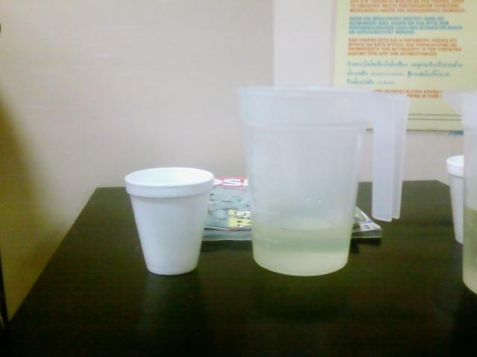
Sickly green stuff was not too good but not that bad either. Next to me was a woman called Wendy, from Williamstown, who had had both breasts removed. Naturally, we had plenty to talk about and I think we both felt it helped pass the time and ease the liquid down. Wendy had been going through the mill for 4 years. We compared notes on how difficult it was to be a focus of attention and the changes in how people approached us. We were joined by a policewoman who had just been diagnosed with breast cancer and was in quite a spin - and scared.
Soon Wendy was taken away and I followed. Had to undress and slip into the white gown with the ribbon at the back. The CT machine was basically a hole with a sliding table.
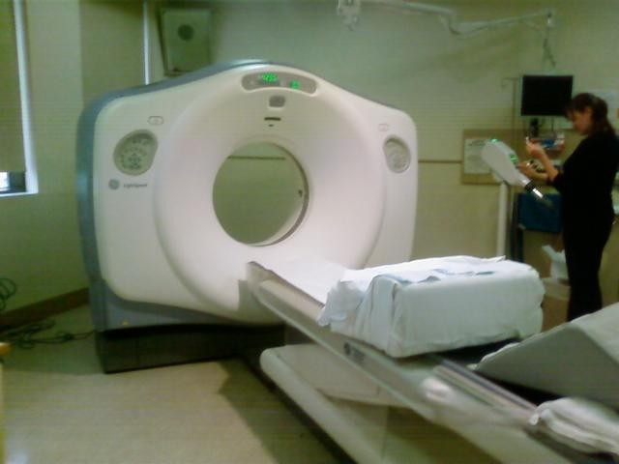
Next to the machine was a curious injecting machine with an ominous glow in its huge calibrated barrel. This suggested they were going to pump gallons of glowing radioactive stuff into me. It was hardly reassuring to be told that it was only 70ml. But why such a big tube?
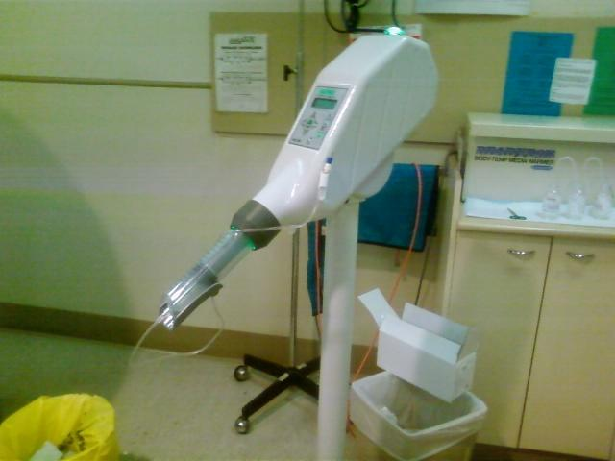
Not that they, the female staff, were in any way intimidating. They were friendly, open and reassuring at every stage. Good on them. They had a kind of practice go in order to line things up properly and then I was moved back and forth while something inside the machine spun. The liquid they had injected had a kind of hot rush to it. They warned me that it would feel as though I had wet myself. They were right - it did. At several points a robotic male American voice told me to hold my breath and then seconds later commanded me to breath.
While I was on the trolley and my vein was hooked up to the machine another kindly woman injected with something radioactive. This was for the bone scan. It would take a couple of hours to work its way through my body. I therefore had go away for a few hours and come back at 1:30pm.
Walked over to RMIT and Lyndal bought me a coffee while we discussed the Avoca Project EOI with some excitement.
On the way I had some passport photos done as my passport has expired and it's one of many little things I feel I need to do to keep my life in order.
On return, further down the corridor I encountered a young but dour Asian nuclear medicine man who strapped me into another machine with a sliding trolley. This was the gamma ray machine.
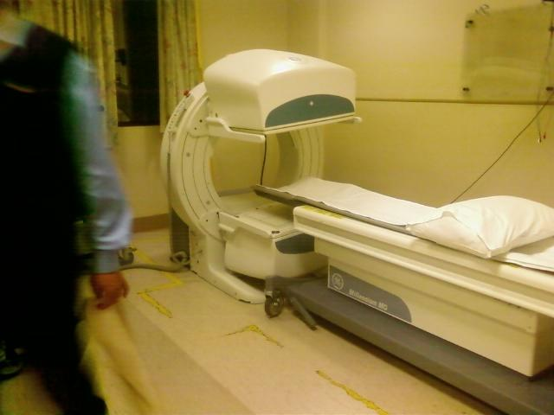
After sliding me into the machine and instructing me to keep still, I lay for some time with my eyes about an inch from what looked like a tiled surface but wasn't. Eventually I could hear a mechanical sound and became aware that I was moving very, very slowly. So slowly that I had to take fixes with my eyes to read any movement. I wondered about all those gamma rays and what they might be doing to my chromosomes. Seemed like a good idea to keep my eyes shut in case my eyeballs were scorched. Once my head and shoulders were out, the machine seemed to take an eternity to get to my feet. At one point I thought he had forgotten about me and that my feet might dissolve under the rays.
But he returned and tilted the machine for another go at my abdomen. This time he said, '30 seconds to go.' and asked me (ominously) if it had hurt! It hadn't hurt at all. Next, I was given a large envelope and told to take it to reception.
At reception, I was told that the bill was more than a thousand dollars but that I would be billed the Medicare gap. This was $214.00. I think I had better keep a running total...
It seemed appropriate to walk home in the rain down Smith St. where I stopped and ate a dreadful dreadlock curry at the Friends of the Earth cafe and read some items about Obama in the Financial Review.

4. Blood on sheets...
November 11th 2008
Not to be read if you want to avoid the personal...making love resulted in a show of blood.
Got up early and showered to find some blood on my thigh. Later, my wife (post-menopausal) reported that she was perplexed to find blood on our sheets as if she had somehow miraculously began to cycle again. My somewhat deflated libido had resisted love making in a clumsy effort to avoid such an event. I had mistakenly thought that enough time had passed. Not so. It seems that my prostate is still bleeding from the needle biopsy - after 12 days. However, my urine is still clear.

5. Clear scan results and CRP
November 11th 2008
Appointment with urologist today. My scans appear to be clear of any further cancer i.e no metastasis.
He put some of the images that I had bought with me from my scans onto a screen and explained the dark bits. Appears that I have a fair bit of degenerative arthritis as well as a small cyst on my left kidney (no problem). We discussed the details of the Radical Prostatectomy and Jeremy Goad drew me some more excellent pictures by way of explanation. The operation takes about 3 hours. He cuts the urethra, removes the prostate and then sews the urethra back onto the bladder. The risk of impotence is because the nerves go very close to the wall of the rectum, and he has to cut close to this wall. In his opinion there is no real defensible advantage to robots or laprascopic surgery other than a quicker recovery time. But I think I prefer an experienced human without too many degrees of separation from what is in front of him. I don't want my fate determined by a mouse. I'll need a catheter for a couple of weeks.
Told him about the blood and it all appeared normal.
I mentioned Martin Ashdown's CRP work and the idea of waiting while I had 6 consecutive blood tests to establish the immune cycle. He seemed quite interested. Martin's email had arrived this morning while I was struggling with CAD to complete my wiring assignment.
We agreed that we would tentatively book in the 11th December for surgery and that would probably leave time for the 6 consecutive blood tests after my needle biopsy heals. Healing should take another 2 weeks.
Martin's email as follows:
Hi Simon....
below are 4 abstracts FYI. As discussed we are conducting cancer clinical trials at the Mayo Clinic (US), Royal Women's hospital Melbourne and soon to start at Peter MacCallum also here in Melbourne. We are using serial measurements of the blood assay - high sensitive C- Reactive Protein (hs-CRP) to establish the best time to apply chemotherapy.
Our work suggests that in order to obtain a complete response chemotherapy (and probably radiotherapy ) needs to be applied at the correct point (a narrow approx' 12 hr window) in a patients repeating ~7 day regulated immune response cycle. CRP is known to be elevated and rise with disease progression in a number of cancer types. CRP is also appreciated to rise and fall with initiation and termination of the immune response.
Our work has demonstrated that CRP is repeatedly oscillating up & down over an approx 7 day cycle in response to the tumor burden in a variety of malignancies. This oscillation suggests a continuous repeating process of the patient's immune system switching "on & off" in response to the tumor. Mouse experiments have shown that appropriately timed chemotherapy can "jam" this response "on" leading to total tumor irradication in advanced disease.
Also our work suggests that when chemotherapy is spectacularly successful in a late stage or advanced patient, it is due to the chemotherapy fortuitously modulating a pre-existing suppressed anti-tumour immune response and not direct tumour toxicity. The 4th abstract discusses the immune suppression in prostate cancer patients. CRP when measured serially (near daily) appears to be a good, cheap, robust surrogate biomarker to time therapy.
WRT your situation....and if you are interested I would suggest that you get six sequential hs-CRP's done (on a Monday, Wed, Fri, Sat, Mon, Wed) thru your GP & local Dorevitch. This may show elevated and oscillating CRP. I would do this once all the after-effects of your needle biopsies have resolved. This may also provide some information to your surgeon pre-op in light of the recent publications...abstracts below. I would be happy to chat to your surgeon to better explain what we are doing in the clinic. If you have any further questions ....don't hesitate to call
best regards
martin.
Cancer. 2008 Jun;112(11):2377-83. (full text) C-reactive protein as a prognostic marker for men with androgen-independent prostate cancer: results from the ASCENT trial.
Beer TM, Lalani AS, Lee S, Mori M, Eilers KM, Curd JG, Henner WD, Ryan CW, Venner P, Ruether JD, Chi KN; ASCENT Investigators.
Division of Hematology & Medical Oncology, Oregon Health & Sciences University, Portland, OR 97239, USA. beert@ohsu.edu
BACKGROUND: Studies of cancer risk and molecular carcinogenesis suggest a role for inflammation in cancer development and progression. The authors sought to determine whether specific blood proteins associated with inflammation predict for outcomes in men with metastatic androgen-independent prostate cancer (AIPC) who are initiating docetaxel-based chemotherapy. METHODS: Baseline plasma samples were stored (-80 degrees C) from 160 of 250 patients enrolled in the AIPC Study of Calcitriol ENhancing Taxotere (ASCENT) trial, a randomized, placebo-controlled trial comparing weekly docetaxel plus high-dose calcitriol with weekly docetaxel. Multiplex immunoassays measured 16 cytokine, chemokine, cardiovascular, or inflammatory markers. The Cox proportional hazards model was used to assess associations between baseline biomarkers, clinical characteristics, and survival. Logistic regression was used for analyses of associations with prostate-specific antigen (PSA) decline. RESULTS: C-reactive protein (CRP) was found to be significantly predictive of a shorter overall survival (hazards ratio [HR] of 1.41 for each natural logarithm [ln] [CRP] increase; 95% confidence interval [95% CI], 1.20-1.65 [P < .0001]). When CRP (continuous) was entered into a multivariate model using 13 baseline clinical variables, only elevated CRP remained a significant predictor (P < .0001) of shorter overall survival. When categorized as normal (8 mg/L), elevated CRP was found to be a significant predictor of shorter overall survival (HR of 2.96; 95% CI, 1.52-5.77 [P = .001]), as was hemoglobin (P = .007). Elevated CRP was also associated with a lower probability of PSA decline (odds ratio of 0.74 for each ln(CRP) increase; 95% CI, 0.60-0.92 [P = .007]). CONCLUSIONS.: Elevated plasma CRP concentrations appear to be a strong predictor of poor survival and lower probability of PSA response to treatment in patients with AIPC who are receiving docetaxel-based therapy. (c) 2008 American Cancer Society.
Urol Int. 2008;80(2):129-33. Epub 2008 Mar 19. (full text)
Simple stratification of survival using bone scan and serum C-reactive protein in prostate cancer patients with metastases.
Nakashima J, Kikuchi E, Miyajima A, Nakagawa K, Oya M, Ohigashi T, Murai M.
Department of Urology, Keio University School of Medicine, Tokyo, Japan. njun@sc.itc.keio.ac.jp
BACKGROUND: IL-6 has been reported to be a significant prognostic factor for prostate cancer and induces synthesis of C-reactive protein (CRP) by hepatocytes. The present study was undertaken to evaluate the clinical value of serum CRP in prostate cancer patients with metastases. METHODS: The prognostic significance of serum CRP as well as tumor histology, extent of disease (EOD) on bone scan, serum levels of prostate-specific antigen (PSA) and alkaline phosphatase (ALP) and hemoglobin was assessed using Cox's proportional hazards model analyses in 126 prostate cancer patients with metastases treated with endocrine therapy. RESULTS: Serum levels of CRP, PSA and ALP significantly increased and hemoglobin significantly decreased with advancing EOD grade. Univariate analysis demonstrated that EOD, CRP, PSA, ALP, hemoglobin and tumor histology are significantly associated with disease-specific survival. Multivariate analysis demonstrated that serum CRP and EOD were significant prognostic factors. The 5-year survival rates in low-risk patients (CRP < or = 0.15 mg/dl and EOD 0.15 mg/dl and EOD > or = 2) were 74 and 24%, respectively. CONCLUSION: These results indicate that a combination of serum CRP and EOD can identify patients with a poor prognosis who may be candidates for innovative treatments among prostate cancer patients with metastases.
BJU Int. 2005 May;95(7):961-2. - (full text)
Comment in: BJU Int. 2005 Aug;96(3):441; author reply 441.
C-reactive protein is significantly associated with prostate-specific antigen and metastatic disease in prostate cancer.
Lehrer S, Diamond EJ, Mamkine B, Droller MJ, Stone NN, Stock RG.
Department of Radiation Oncology, Mount Sinai Medical Center, New York, NY 10029, USA. stevenlehrer@hotmail.com
OBJECTIVE: To further analyse the relationship of c-reactive protein (CRP) levels to prostate cancer, by measuring CRP in men with prostate cancer and benign prostatic hypertrophy (BPH), as chronic inflammation has long been linked to cancers with an infectious cause and CRP is a nonspecific marker for inflammation, associated with prostate cancer incidence and progression. PATIENTS AND METHODS: Data from 114 men, most of whom had had radioactive seeds implanted, were evaluated from November 1990 to April 2002. In addition, 27 men were included who had biopsy-confirmed BPH. CRP was assessed with an automated chemiluminometric high-sensitivity assay kit. RESULTS: There was no significant difference in CRP levels in men with localized prostate cancer or BPH but levels were significantly higher in men with bone metastases. There was also a significant correlation of CRP level with prostate-specific antigen (PSA) in those with cancer. Because PSA is correlated with disease stage, multiple linear regression was used with CRP as the dependent variable, and PSA and disease stage as independent variables. The regression was significant overall (P < 0.001) and the effect of disease stage on CRP (P < 0.001) was independent of the effect of PSA level (P = 0.001). CONCLUSION: The strong association of CRP with PSA, independent of tumour stage, suggests that inflammation might be fundamental in prostate cancer, and that chronic inflammation may be a legitimate target for prostate cancer chemoprevention and treatment.
Clin Cancer Res. 2007 Dec 1;13(23):6947-58. (full text) .
CD8+ Foxp3+ regulatory T cells mediate immunosuppression in prostate cancer. Kiniwa Y, Miyahara Y, Wang HY, Peng W, Peng G, Wheeler TM, Thompson TC, Old LJ, Wang RF.
Department of Pathology, The Center for Cell and Gene Therapy, Baylor Colleg of Medicine, Houston, Texas 77030, USA.
PURPOSE: Although elevated proportions of CD4(+)CD25(+) regulatory T (Treg) cells have been shown in several types of cancers, very little is known about the existence and function of CD8(+) Treg cells in prostate cancer. In this study, we investigated prostate tumor-derived CD8(+) Treg cells and their function. EXPERIMENTAL DESIGN: Tumor-infiltrating lymphocytes (TIL) from fresh tumor specimens of patients with prostate cancer were generated and subjected to phenotypic and suppressive function analyses. In particular, we investigated the role and function CD8(+) Treg cells in prostate cancer. RESULTS: We show that high percentages of CD4(+)CD25(+) T cells are probably present in the majority (70%) of prostate TILs. Remarkably, both CD4(+) and CD8(+) T-cell subpopulations possessed potent suppressive activity. T-cell cloning and fluorescence-activated cell sorting analyses showed the presence of CD8(+)CD25(+) Treg cell clones that expressed FoxP3 and suppressed naïve T-cell proliferation, in addition to the previously known CD4(+)CD25(+) Treg cells. These CD8(+) Treg cells suppressed naïve T-cell proliferation mainly through a cell contact-dependent mechanism. Importantly, the suppressive function of CD8(+) Treg cells could be reversed by human Toll-like receptor 8 (TLR8) signalling. CONCLUSION: Our study shows that like CD4(+)CD25(+) Treg cells, CD8(+) Foxp3(+) Treg cells present in prostate tumor-derived TILs suppress immune responses and that their suppressive function can be regulated by TLR8 ligands, raising the possibility that the manipulation of Treg cell function by TLR8 ligands could improve the efficacy of immunotherapy for prostate cancer patients.

6. Clogging not clearing the decks
November 23rd 2008
Seems like I've been too busy to write much or to even think about what might lie ahead.
Apart from a quick dash to Sydney for my niece Anna's wedding, exams, assignments, and a November 22nd deadline for a Green Precincts Fund EOI, I've set myself some ridiculous goals to achieve before the 11th December: 1. build a shed in Apollo Bay 2. Finish the Eastern Wall in Melbourne. Spent today laying bricks up on top of my 4m trestles. Heading down to Apollo Bay with the shed tomorrow. The ORCA AGM was able to go ahead without me being there.
Concerned about having the time for the CRP blood tests. Will need to ring Dr Blanch tomorrow or go direct to pathology.
Along the way it's been moving to have received so much good advice and well wishes from friends and relatives.
1. Build up my iron levels. This from James who works for the blood bank. It seems Jehovah's witnesses (who don't have transfusions) have quite good operational outcomes because a surgeons are quite careful not to have them need transfusions and b. they have high iron levels. Susan's been cooking up lots of meaty dishes.
2. Allow plenty of time for recovery. This has been stressed my several people including Charlie who said it took him nearly a year before he was his usual self. Jen's brother (a farmer) said overdoing it leads to blood in the urine (not good).
3. Take more note of the impact of all this on Susan.
On a more intimate note. No more blood in semen but I have to say my libido has sagged - somewhat. Purely psychological - but nevertheless real. So, my chances of making lots of hay while he sun is still shining are diminished. Oh well...
The trouble with surgery is that it is not reversible. I harbour the notion that it might all just go away. I certainly feel as if there is nothing wrong with me. Somehow, I expect that notion to reflect the power of my immune system.

7. CRP 1 + my frayed friend
November 27th 2008
Wandered up the road to the pathologist this morning where, at about 10:15am I was drained of the first of 6 blood samples to test for highly reactive C-Reactive Protein (CRP).
The place was quite empty. Apparently, the morning rush (the people fasting) had just finished. Chinese pathologist made 6 photocopies of my doctor's request and she was quick and efficient with her needle work. Fortunately, I think it will be bulk billed. That put a spring into my step, and I didn't mind at all that she gave me a short lecture on how important it as to follow my Doctor's orders to the letter.
Later I visited my old friend, Roger. How I feel for him. His prostate story very similar to mine except that he had his cut out 3 weeks ago. He moved slowly, was looking frayed, and warned me about the extended recovery period. Painful to sit, catheter very unpleasant. He was in hospital 3 days and had the catheter removed after a week. He said several times that he felt mutilated.
He described his post operative experience as difficult to sleep except on your back because it's painful to roll on your side. Not talked about is the fact that the penis is shortened by being drawn into the space the prostate previously occupied. Yikes! Perhaps I should be more anxious than I am...

8. CRP 2
November 28th 2008
Hospital has sent me a few other tests associated with pre op radical prostatectomy: FBE (Full blood examination), UTE/creatanine (kidney function), ECG, msu (mid stream urine), crossmatch.
Seems to me that if I'm having these blood tests then they might as well get the most out of each sample.
The waiting room was full to brimming this time. Mainly older, sick looking folk with walking sticks and resolute expressions. We all held numbers. However, my number was called quite quickly even though they were there before me. When I pulled out my phone to take some photos, the pathologist revealed that she too had been on a cancer journey.
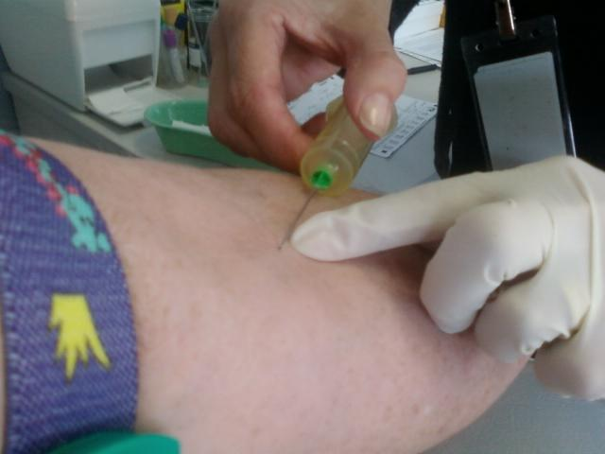
She took about 3 vials of blood for the other tests and we managed to get the CRP done at about 10:20am well aligned with the timing of the first one. I'll be back tomorrow, Saturday for the next one.
The ECG was in another room. She shaved some spots from my hairy chest and wired me up. But nothing seemed to happen.
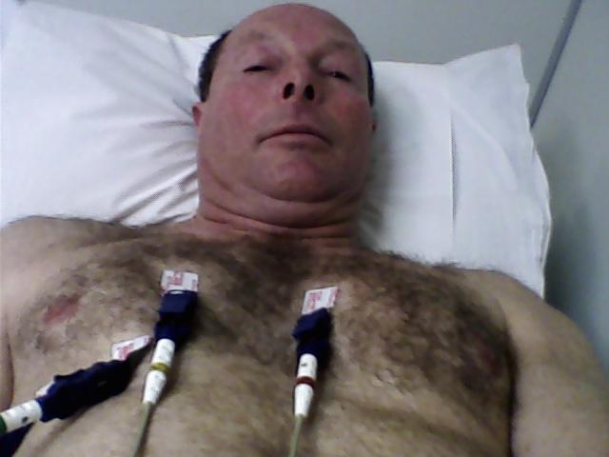

9. CRP 3 + intimations...
November 29th 2008
My arm is starting to ache a little from all this trainspotting. Arrived early, expecting a morning rush but the pathologist was empty.
As timing is important, I used up a little of it by reading some of the documents about prostate cancer the urologist had given me about 3 weeks ago. Just hadn't got round to them. First off, I seem to have been spelling Gleeson (sic) wrong - its Gleason. Second, it hadn't occurred to me that this could possibly kill me. I had assumed that death was the result of the 'do nothing' option.
...up to 86% of men with localised cancer live for at least 10 years, and up to 78% are recurrence free during that time.
Now, these are pretty good odds but reading it shook my complacent assumption that I was somehow immortal. By that I mean I'm just not ready to check out - even in 10 years. I think I been quietly counting on another 20 years, at least. No doubt coming to terms with mortality is just part of growing up. Apart from a few close shaves, I don't really think I've had to come to terms with my own death before. But then, probably no one is ever ready for this - except in films...
There were also some references to Partin Tables and nomograms that sound interesting and worth following up. But a quick look at the Partin tables requires a better understanding of my clinical stage (I'm assuming T2c). According to my readings of these tables, there is a mere 15% probability that the cancer is confined to the prostate, 45% CP - Capsular penetration, 22% SV - Seminal vesicle involvement, 18% LN - Lymph node involvement. Yikes! That's an 85% chance that it has spread.
By about 10:10am a few old folks with walking sticks had arrived and it occurred to me that I might now be one of them.
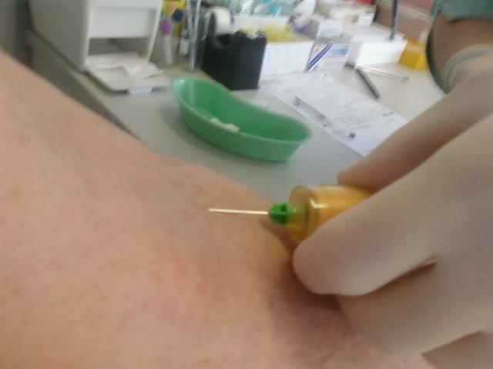
This time the pathologist was quite talkative and we discussed the film 'Australia' (Susan and I saw it in an empty cinema yesterday evening). She said that she heard it was a dog of a film. I said that Hugh Jackman was not such a good casting choice because the role needed someone more laconic and that I enjoyed the sight of Nicole Kidman's bottom (neither of us thought much of the rest of Nicole Kidman).
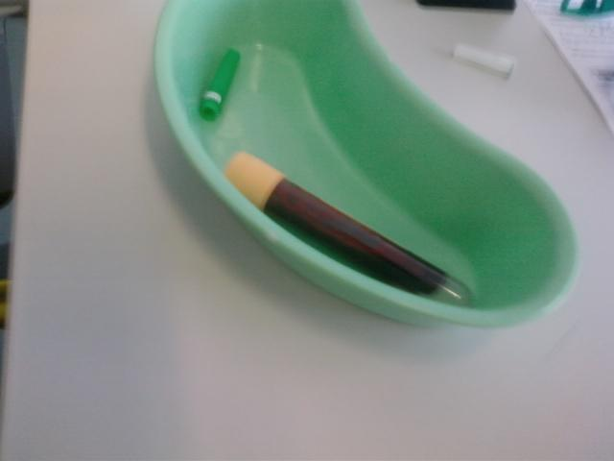

10. CRP 4 + marketing target
December 1st 2008
The CRP is now routine. Maybe a little early today at about 10:05am.
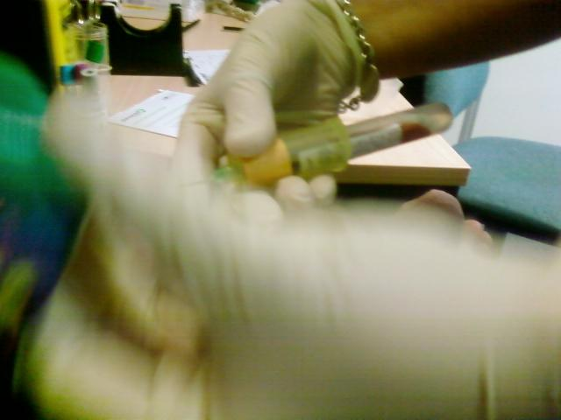
It seems my condition has prompted the marketeers to action. A letter arrived today from someone called Marshall Tate in Brussels, Belgium addressing me as 'Dear Friend' and offering me, 'a powerful erection guaranteed in 5 minutes and available NON-STOP for 24 HOURS!'
All I need to do is send Au$99.90 for 4 packs of STIFF strips. There was a testimonial from Michael W. "Never have I had such an erection in my whole life...even when I was 20 years old!.." and Rob G. says, " I became a new man...".
I also had a phone call from someone in Launceston, Tasmania called Richard Webster who wanted to send me his 'free report' on glyconutrients. He said glyconutrients are the hot area of research for university scientists.
I wonder what's next?

11. CRP 5 + pre-op briefing
December 3rd 2008
Called in to the Mercy yesterday arvo to pay a few bills and attend a pre-op briefing with Priscilla. She was refreshingly forthright.
I started off by telling her that I was scaring myself with the Partin Tables. She re-assured me that they wouldn't be doing the operation if there was doubt about it's success.
After filling in one of the usual forms about allergies etc. she then assured me the hospital room would be dingy, small, either overheated, or too cold, the window wouldn't open, the nurses would be nasty to me, and the food would be awful. Plus, it would costs me heaps of money...I liked her.
She produced a couple of catheters, an overnight one and a travelling leg model. Then demonstrated how the tube blew up like a balloon so that it wouldn't slide out of the bladder. We talked about pelvic floor exercises, and she pretty much gave me a blow by blow description of what I could expect when I woke up and each day after.
Seems I'll be in hospital for 5-6 days and the catheter comes out a week later, 23rd December. I raised the possibility of taking video of the operation. She said I needed to ask the surgeon...
CRP #5 was quick. The Indian pathologist found a different spot on my arm as I'm beginning to look a little punctured and red. She was surprised at me taking a photo.
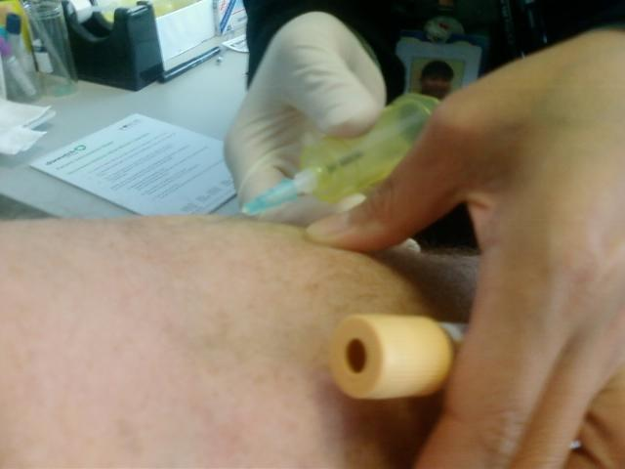

12. CRP 6 + medical intuitive
December 6th 2008
6th and last CRP on Friday. Rang Martin who said they had done the wrong test on one batch (retrievable). Then off to Apollo Bay with a trailer load of bricks, timber and scaffolding pipes. Arrived just in time for the ORCA foreshore gathering.
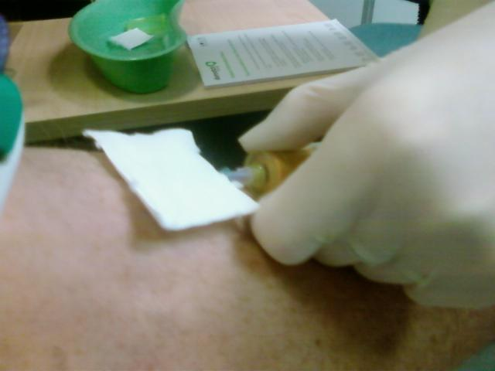
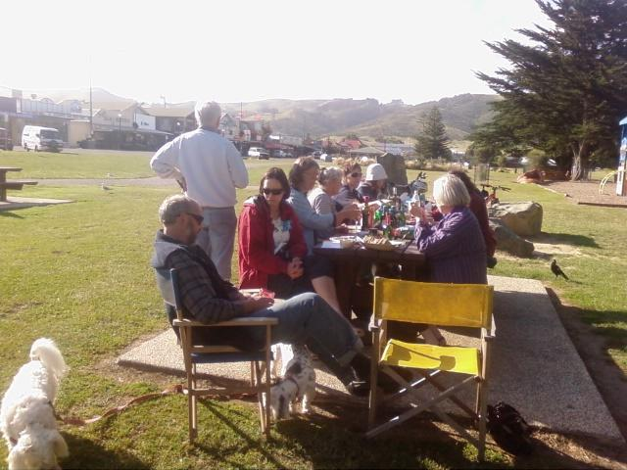
By the time I'd collected tree guards and posts, dug the holes etc., it took me all day (Saturday) to plant 35 Messmates in order to extend the plantation on the southern slope of the Stanley paddock.
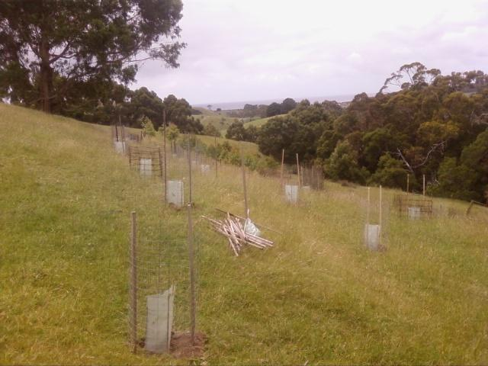
Clambering about the hills and digging was good exercise. Spent the day fatalistically considering that it might be last thing I do down there. However, to me, planting trees seems like a reasonable final action. Sunday was spent putting things in order: cleaning out the gutters on the hut, digging the thistles on the north face, generally tidying up. Resisted a last-minute inclination to cut up a load of firewood for winter. Hard to imagine what it will be like not being able to do these kinds of things for 10 weeks.
My daughter Bonnie made an appointment for me to see Inna Segal, a medical intuitive. Her place was in Caulfield. It took me about an hour to get there - but arrived bang on time. It was a fairly new semi-detached house with a notice at the door to take off shoes. In my hurry to leave, I'd not bothered with socks and wondered if she would mind bare feet. I needn't have worried. The door was opened by a man (perhaps her son) who said I had the time wrong. Although I'm often a day early, this time I was pretty sure I had it right. He then consulted a calendar and discovered a note about the time and that he hadn't written the appointment down.
He was apologetic and disappeared a few times (to talk to Inna) before giving me a consolation CD called 'Create Perfect Health' with a smiling Inna on the front. Not sure what I was expecting. I listened to the CD on the way home. It appeared to be about allowing a divine healing light to cleanse my body or toxins and disease. I tried to go with it and remain open, aware that I might be ill disposed to it all due to the botched appointment. But to properly benefit, I'd have to put my rationality aside. I'm just not the kind of person who can repeat affirmations about divine energy and white light without feeling foolish and slightly futile. Nice of Bonnie to think of me though.
Hoping to hear from Martin today about the CRP data and what it reveals...

13. The Ashdown Cycle
December 10th 2008
The CRP tests have given Martin Ashdown the data to pick up my oscillation. It appears my cycle has a periodicity of about 6 days. I'm not sure how to display the vertical line that occurs at 7.5 days (format incompatibility). This line marks the treatment window. When treatment occurs in this window the immune system is stimulated into action regardless of the type of cancer.
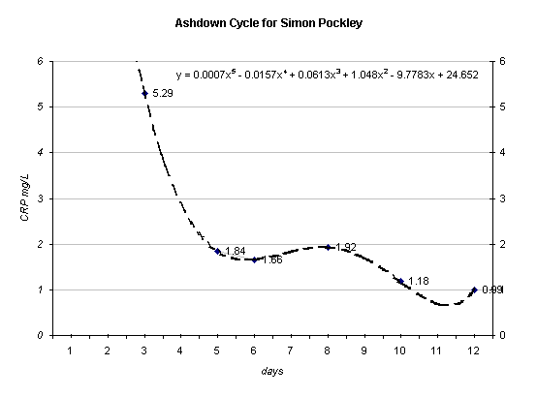
CRP is also appreciated to rise and fall with initiation and termination of the immune response. Our work has demonstrated that CRP is repeatedly oscillating up & down over an approx 7 day cycle in response to the tumor burden in a variety of malignancies. This oscillation suggests a continuous repeating process of the patient's immune system switching "on & off" in response to the tumour. Mouse experiments have shown that appropriately timed chemotherapy can "jam" this response "on" leading to total tumour irradication in advanced disease.
Also our work suggests that when chemotherapy is spectacularly successful in a late stage or advanced patient, it is due to the chemotherapy fortuitously modulating a pre-existing suppressed anti-tumour immune response and not direct tumour toxicity. The 4th abstract discusses the immune suppression in prostate cancer patients. CRP when measured serially (near daily) appears to be a good, cheap, robust surrogate biomarker to time therapy.
As timing is the key to this form of treatment, I asked Martin if the timing of the surgery was important. Given my cycle, it would appear that the 11th is actually a good day for surgery (6 days after the 5th December when I had my last CRP measurement). As I understand it, the notion of surgical vaccination means that my body will be responding to the damage inflicted by the knife at a point just left of peak and within the treatment window (this is good).
Martin's work is at the frontier of the new oncology. Should the cancer come back to bite me, then this knowledge could direct the timing of further treatment and give me better chance.
I had a call from urologist this morning, he said they were not set up for video but that he would take some stills for me. I'd also asked him whether the pathologists report on my slightly enlarged left seminal vesicle set off any alarms. He said it was normal for them to be uneven and that my clinical stage was T1c. I'd rated it at T2c.
Running around today tidying up my affairs and basking in all the attention that I'm getting from friends and relatives. It feels good and I'm certainly not alone or isolated. How lucky I am!

14. Sister morphine
December 12th 2008
Here I lie in my hospital bed...rattly voice and a little hazy. It's morning and painful to move...
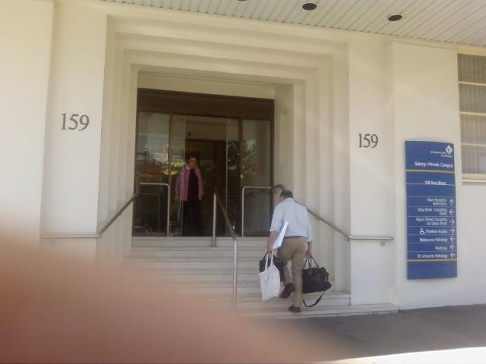
Yesterday morning, after the check in process, my nurse, Daniel measured me up for some latex stockings. These are to stop me getting embolisms while I lie around. He attached wrist and ankle bracelets and got me to change into the backless hospital gown.
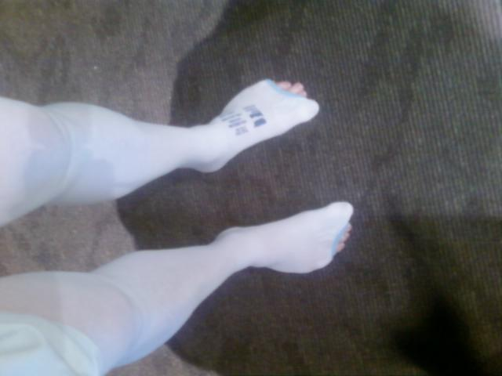
I was then wheeled off to the lower ground floor where I was given a red hat. After a bit of a wait where people were wheeled in and out the anaesthetist made and entry followed by Jeremy (urologist) who introduced me to his assistant. I was the first up in the afternoon surgery. I reminded Jeremy about taking photos. He had left his camera behind but was confident he could borrow one.
Wheeled into the operating theatre. From then on, I can't remember much.
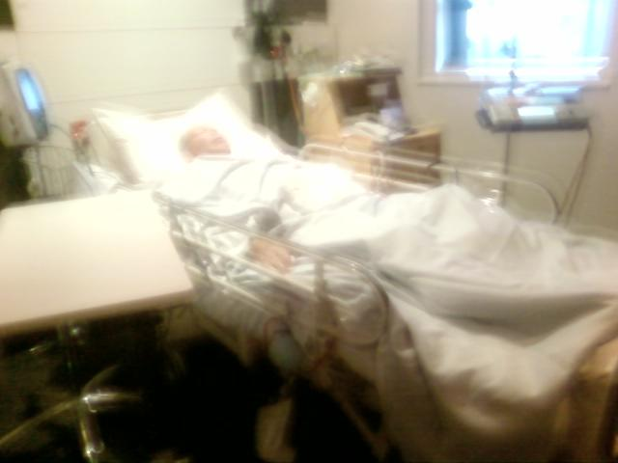
Susan and Bonnie appeared, and someone rang me...I had a wave of nausea as Jeremy arrived on his way out...just a blur. Jane, the night nurse, woke me on the hour to check blood pressure, drips and the various tubes that drain me and feed me saline, Panadol and morphine...
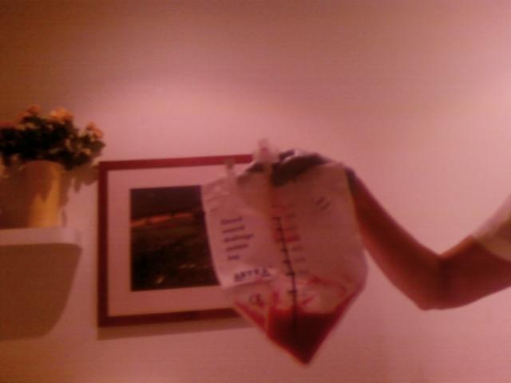
There is a bag on one side of the bed below me that receives blood red urine.
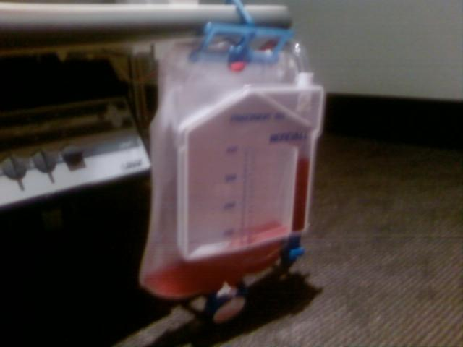
and another bag on the right that receives blood red liquid draining from the wound.
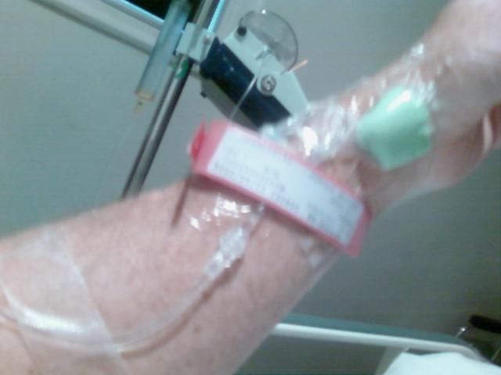
These bags are regularly emptied by the nurses. On my left leg is the tube to the catheter just above the latex stocking.
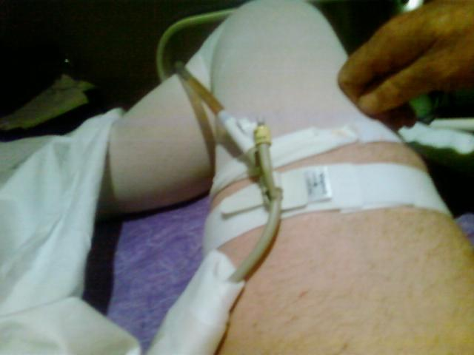
On my right side is the tube draining the site of the operation. My bladder seems bloated but they assure me I'm draining. It's a curious (unpleasant) feeling wanting to pee but not being able to.
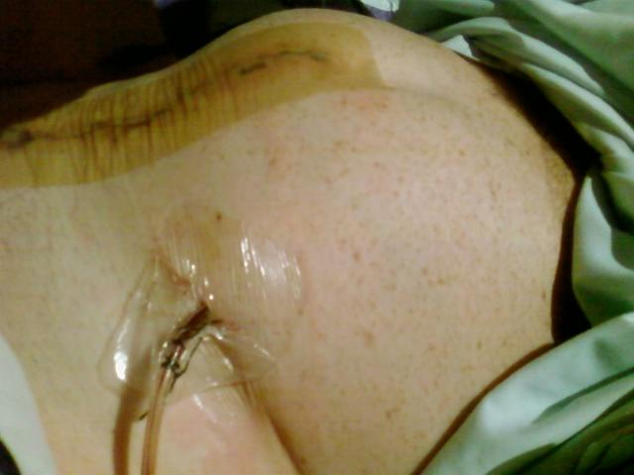
Not a pretty sight at all. Have to stop now....

15. go-between for fluids
December 12th 2008
Getting a bit queasy, earlier. Priscilla visited and assured me the bladder bloat was normal. She said the fluids would suddenly pass-through more rapidly and that my tummy should start to rumble.
She was right. Daniel decided to wash me and with Mari's help they got me up and into a chair.
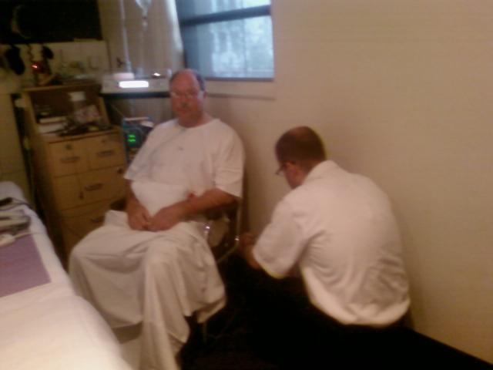
Susan arrived and read some 'Lark Rise to Candleford' to me for about an hour - which was nice. Another woman came a took some more blood. Then Vivienne the physiotherapist, got me doing more breathing exercises and tried to get me to cough. I was weak as water. But all the activity got the fluids going and I went from 40ml per hour to 150ml per hour.
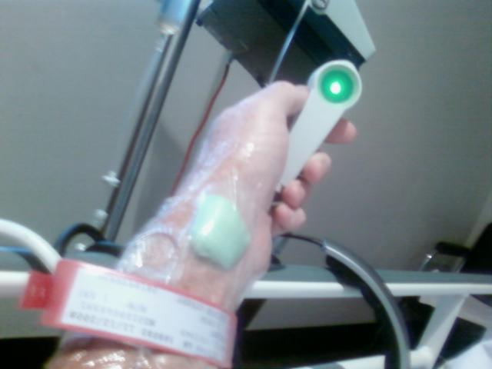
Regret that the nausea is making the morphine unattractive. Seems like I'm just a go between for fluids at the moment. They go in through my arm and out through the catheter and blood drain. Nothing to eat or drink. Perhaps that's what is meant by 'nil by mouth.'

16. blessing the shower
December 13th 2008
An unpleasant, uncomfortable long night with a fever and a peculiar bed-bound discomfort where the body seems to be pressed into all the hard bits by inertia, gravity and helplessness.
The morphine was taken away because I wasn't using it. An Irish night nurse (lovely voice) only came in a couple of times during the night. Once when the alarm on my drip went off because it was empty. Call from my brother Tim this morning cheered me up as he keeps it all in perspective. A rough nurse took over the morning shift. She pulled at my tubes and kept turning on the light so that it beamed straight into my eyes and then left the room. But later, she suggested I have a shower. A great idea!
The logistics of moving me with all the equipment and tubes was complex. But we made it to bathroom and once we'd managed to untangle the gown and the tubes and then pull the drip through the sleeve, she left me to it.
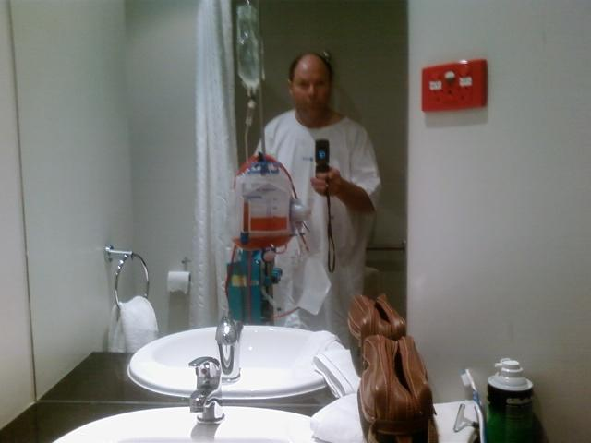
I think I was meant to sit down on a plastic chair but it was such a relief to do my teeth and have a shave that it seemed better to stand for as long as I could. It's now about an hour later and I'm still standing while I write this. Vivienne, the physio is coming back to try to get me to cough. The longer I stand the easier it seems to be - to be upright. Ahhh what a blessing is the shower...
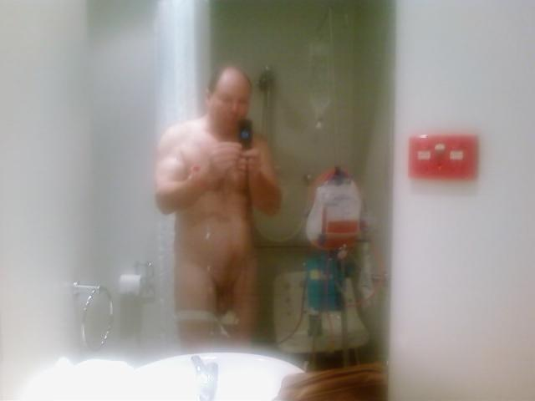
I was able to see the wound in the mirror and the extent to which I'd been shaved (like a plucked chicken). My poor old zab (penis) is shrivelled and black with bruising. Together with my still bloated bladder I'm not a pretty site.
I had a hearty lunch of beef and mushroom pie with peas and pumpkin. Susan arrived and massaged my feet and neck which was nice. She is not sleeping well. We hung out for a while, and she has now gone off to a family Xmas party in Williamstown. I'm hoping she will be able to collect the solar panel data for me this evening but it's very grey outside and the inverters may turn off early. If I can get the data, then I'll send a happy day collating and displaying the results - tomorrow I've been warned, to expect 3rd day blues.

17. 3rd day blues?
December 14th 2008
Tim rang me this morning at about 6:30am and we talked about slipping boats. I then discovered my bed was a bit a train wreck - a slip way in itself. I don't know what happened, but the nurses are amused and can't fix it.
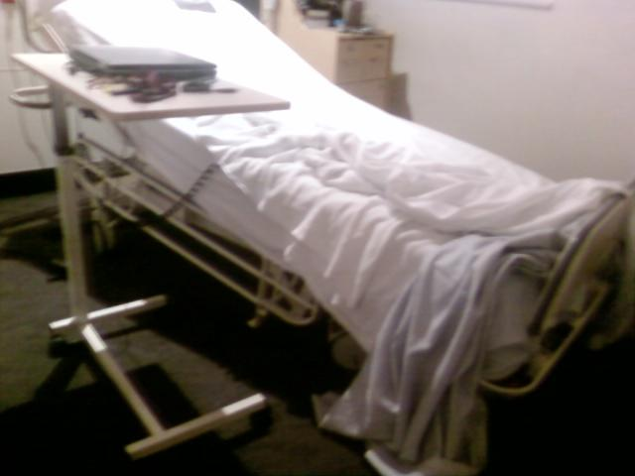
But I do recall spending the night struggling to get back uphill with the thing creaking and groaning. It's downhill all the way. Perhaps this is how the 3rd day blues are induced?
Apart form struggling to get back uphill, I had a good night without so many tubes. At one point my leg catheter was not draining into the night catheter but the night nurse, Cath, helped me out. I was surprised at how full the night catheter was in the morning. Still plenty of blood though.
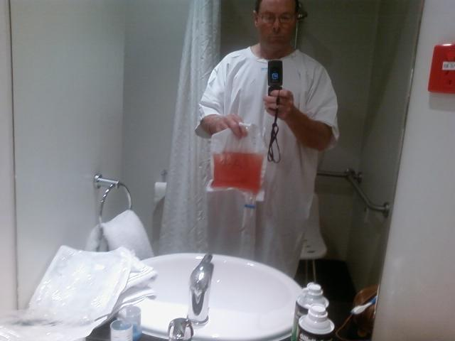
I'd been instructed how to empty it and then rinse it out and hang it up to dry. The document is called ' At home with your catheter.' After attending to the urine side of things, I did my teeth, had a shave and then a great shower. The hardest thing was getting the latex stockings off and picking up the dropped soap. Inspecting myself in the mirror shows how swollen my scrotum has become - perhaps full of fluids and gore. Other than that and the persistence or blood in the urine, I seem to be doing just fine.
There was a painful moment last night when Cheryl, the Tongan afternoon nurse, took out the stitches that held my drain tube in. The pain was not so much from the stitches but from the removal of the tube itself.
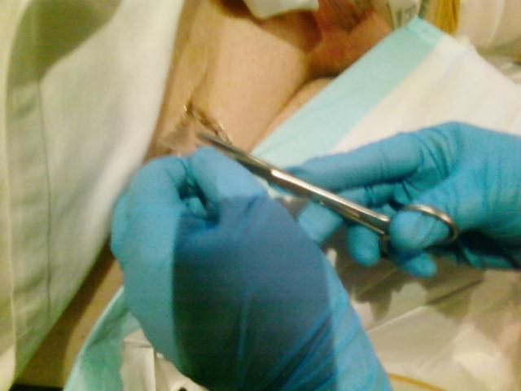
It was quite long, and I could feel it being withdrawn from deep inside - ouch! But so good not to have it anymore and to be relatively tube free. I've done a couple of laps of the corridor and am sitting in my Kimono (made by Susan) eagerly awaiting breakfast.

18. 4th day - out tomorrow
December 15th 2008
Up early to do the catheter wash, shave and shower. The nurse was keen for me to have a Panadol. We agreed that I'd take the Panadol if she removed the drip needle from my arm. No doubt she would have removed it anyway.
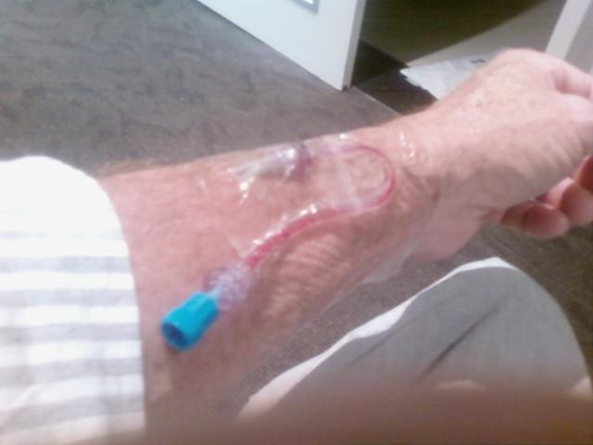
I'm wondering if I'll be allowed to go home today. Seems to me that I'm now functioning properly. While so much of this blog has been about blood and urine, by yesterday evening my main concern was the need for a poo. After 3 days I was beginning to feel like I needed one. Sat on the toilet a few times and waited for some form of automatic body process to begin - but nothing happened. I wondered if it would be painful. But about 6:30pm there was movement and relief. No pain at all.
The nurses keep asking me if I've passed wind. I interpret that to mean have I farted? There's something very basic about a place where you can tell someone you've had a poo and they are pleased for you. Need to get out of here.
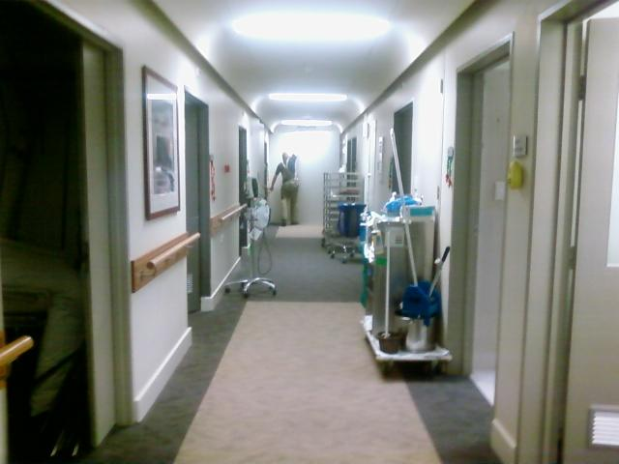

19. Pathology + the gory bits
December 15th 2008
Jeremy came by this evening with a CD of the stills from the operation. He said that the pathology of the prostate was good except that one part of the tumour was just a mm from the edge. This is too close for comfort, but he thinks we got it in time (before it spread). So, as far as I'm concerned that's good news!
So, it looks like I'm out of here tomorrow. My sister Jane wants a shot of the Kimono I've been wearing, and this may help shield any sensitive viewers from the images below.
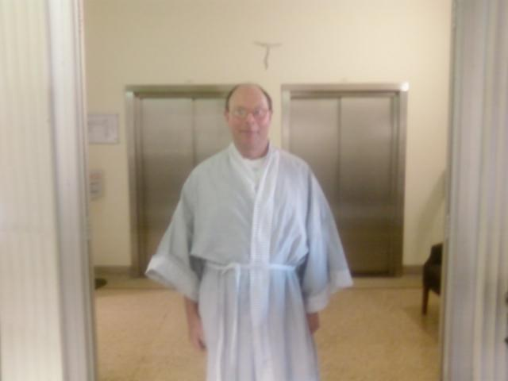
It's curious looking into the entrails of your own body. The complexity of the organism. The skill of the surgeon. The ability to recover. As far as I can sequence the stills, they go like this:
1. They open me up. The prostate is just below the sucker.
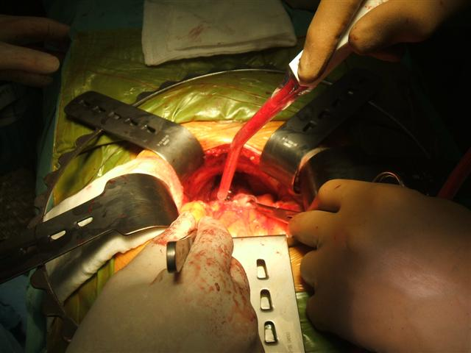
2. The prostate is now visible. The white thing (lower centre) is a sponge.
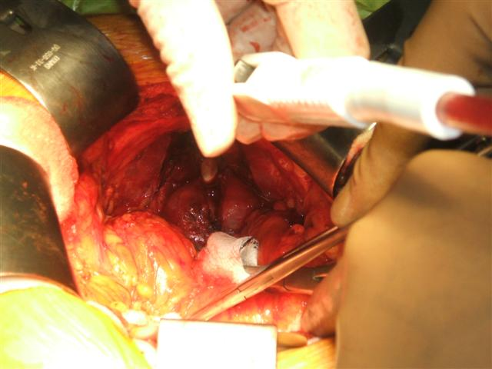
3. This is a closer view of the prostate being dissected from the urethra (white clip top centre)
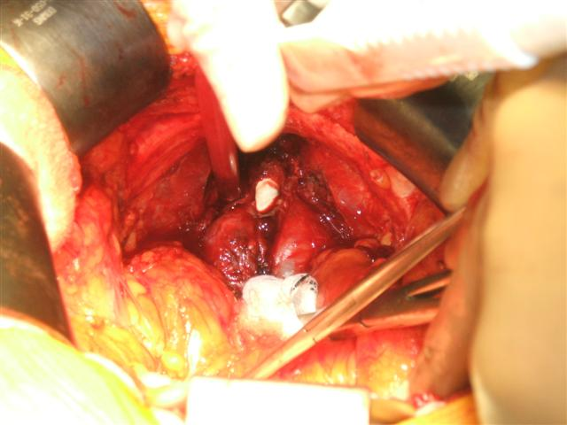
4. The catheter is fed through the prostate to help remove it. White cloth is to mop up blood.
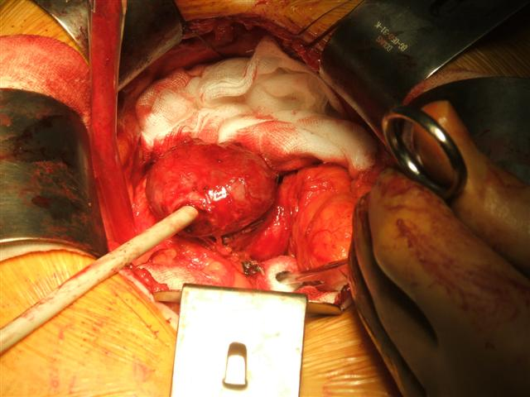
5. Here's the intact prostate and the seminal vesicles to the right
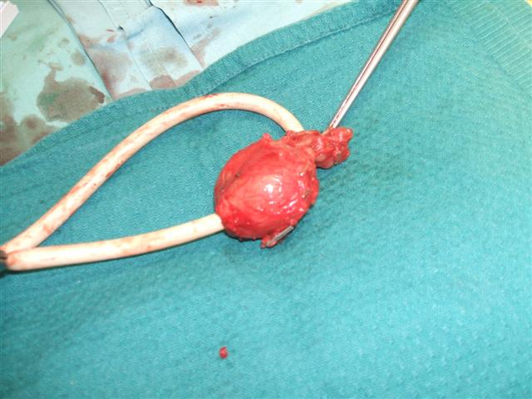
6. The urethra is joined back to the bladder, and I'm stitched up
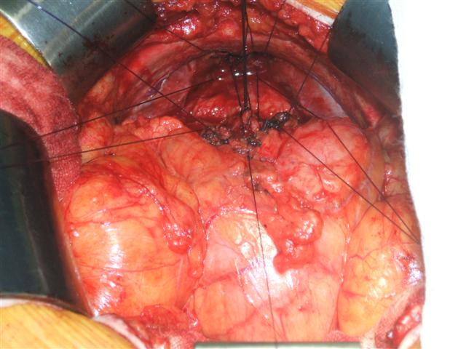

21. Being home
December 16th 2008
It's 6:30am and I'm packed and ready. I've been fortunate indeed to have so many good people travelling along with me. So, thanks to all of you who have been there, sent texts, made comments, phoned me. It's been incredibly important to me and probably why I have done so well. All I can say is thank you.
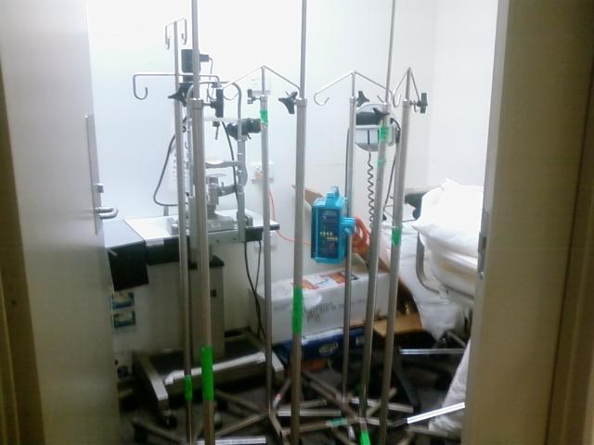
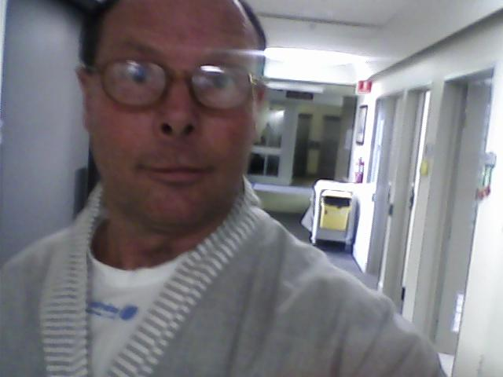

21. Being home
December 17th 2008
Tomorrow I may be able to stop being an invalid. But nothing quite like being in your own bed and being looked after. Had to sleep on Susan's side of the bed (left) due to the catheter on my left leg. This meant that the cat bit her foot in the morning (cat usually bites my foot as a signal to get up).
She suggested I put a pillow between my knees (pregnancy trick) and this allowed me to get some sleep on my side. Usually find it hard to sleep on my back. Have got into the habit of taking a picture of the catheter in the morning while I'm still connected. Maybe I'll sequence these into some kind of montage.
Woke up with more freedom of movement than the day before and had a long shower where I removed the curious skin-like dressings from the cut and the drain hole so that the air could get to them. It felt good to be another step away from the operation. I seem to have come home with an itchy rash on back, probably due to spending so long on my back and sticking to the sheets of the hospital bed. The scrotum elephantitis seems to be shrinking but is still a little uncomfortable. Coughing stills hurts but is getting easier.
Susan and I spent most of the day and evening on the couch glued to 'The Wire' (Season 3). In the evening, we walked down to Merri Station (100 metres). On the way I was blessed by one of the Greek women - which was nice. I seem to have lost my taste for coffee and have been drinking tea and cheese on toast.

22. Home & away with catheter
December 23rd 2008
A catheter can be quite useful from time-to-time. It certainly makes it easier to accurately water the lemon tree. But it introduces a level of obstruction that can be quite inhibiting and it sure feels good to have the tube removed.
This morning, Priscilla the urology nurse, gave me a shot of antibiotics in the bum and injected some saline solution through the catheter into my bladder. Then she pulled out the tube (didn't hurt) and asked me to demonstrate my ability to to s s stop and s s start a pee over a kind of portable toilet. She then gave me a bag of pads (like nappies) which you stuff into your undies. I'm optimistic because I seem to have some control over when I pee. Getting in and out of cars and standing up from sitting seems to involve a warm feeling associated with leakage.
For anyone who's never had a catheter, you still have the urge to pee, but not the direct capacity. It just seems to happen of its own accord. The main problem that I've experienced with the catheter is where the rubber tube goes into my zab (penis). It's somewhat tender and the more I walk the more tender it gets.
It took me a day or so to realise that the way the nurse had set it up on my leg was wrong. First, I moved the holding band round to my inner thigh where it was a little more comfortable. Second, I tightened the rubber loop that holds the main drain tube. This was too loose and, as a result, when I was walking up the street I could feel the whole thing sliding down my leg and tugging at the tube in my bladder. It's a trade off between being tight enough to hold a full bag and loose enough not to cut of the circulation in my leg.
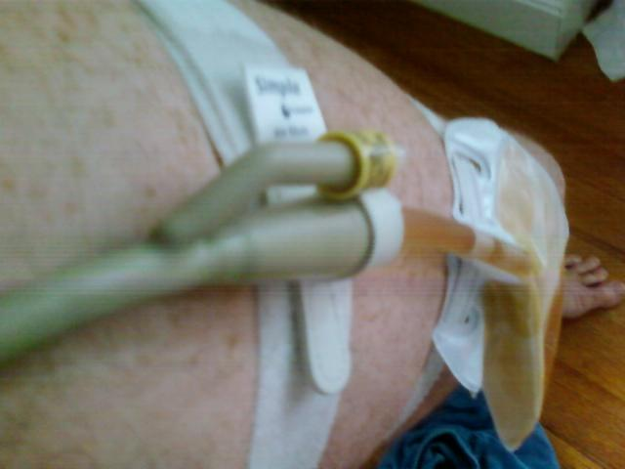
I've also learnt to take it all off when I have a shower so that the elastic leg bands don't get wet. This just leaves the tube hanging down and is much easier to clean.
A lesser problem is that the leg bag (being plastic) is quite sweaty. A delux model catheter would have some kind of non-sweat backing, a rounder tap (so that it doesn't catch) and some form of non-constricting (crimping) entry and exit points. Being a compulsive measurer, I do like the ml graduations. It's quite reassuring to see a good 500ml in the morning night bag. My practice, at night, was to leave the bag on the floor and make sure my leg was aligned to the edge of the bed so that the leg bag wasn't crimping. Anxiety about crimping disturbed sleep.
Yesterday I had a call (mobile). One goes into a special space on mobile calls that can involve walking around a bit. At one point I was out in the street and some passers by looked at me strangely. Of course, I was in shorts (due to the heat) with my catheter hanging out. Could this me the new punk look for the over 50s?
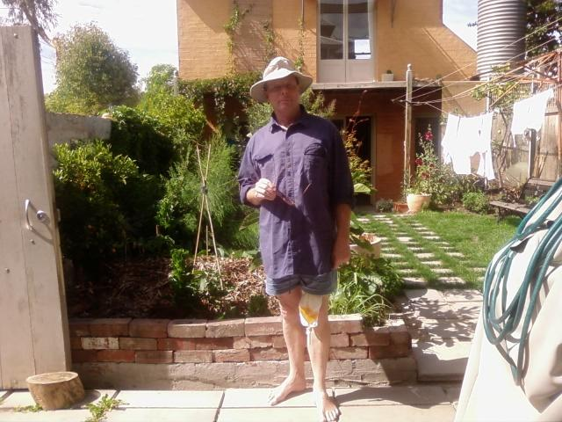
A friend sent me this image: 'On Cup day a few weeks ago I saw a 40ish woman getting out of the train, wearing her best purple satin flowing dress, obligatory little feather hat. It was obvious that she had had the odd drink during the day. Her extremely full leg bag had obviously slipped down and was hanging somewhere on the inside of her knee. It was a very curious sight. Must have been quite uncomfortable to walk with it.'
It's been a week (last Tuesday) since I came home. I'm amazed at the body's ability to repair itself. On Wednesday, I was able to walk up to Northcote Plaza (about 2K) without any difficulty or exhaustion. We went to see a film and saw 'Slumdog Millionaire'. I had been warned that it might be painful to sit, and it was a little, but this has mainly passed now. From Thursday on, I felt even better and 20% more agile each day. By agile, I mean able to stand on one leg and put on my socks, able to do up my shoe laces, able to pick things off the floor, comfortable sitting, able to lie in comfortable positions in bed, able to go up stairs normally - not one step at a time. Able to walk as far as I liked.
Since the operation I've been taking two capsules of 500 IU of Vitamin E each morning along with a Osterlin Vitamin D (25mcg cholecalciferol) and since yesterday, two antioxidant compound tablets morning and evening. Prior to the operation I was taking one of the antioxidant tablets each day and two 1000mg Fish oil capsules with a vitamin D.
The secret to this miraculous recovery, I put down to the 3G modem and your daily encouragement.

23. Sex after surgery
February 26th 2020
Written in December 27th 2008: No point in being in denial that prostate cancer impacts on sexual function. Seeing those little seminal vesicles on the table hanging on to the prostate, and now removed from me, is seeing a whole part of what has become my adult being - severed.
On Saturday (16 days after the chop) I was walking the hills in Apollo Bay looking for the last of the spring thistles to chip and thinking about what it might be like to be non-sexual. It occurred to me that I had enjoyed my first 12 or 13 years without much sexual activity and that maybe this was the reality of old age and perhaps the next decade or so. However, thoughts like this don't come from nowhere and by the time I got back to the hut my libido had kicked into gear and I was fairly keen to make love to my wife, Susan.
So now it's 12 years later February 2020, and love making is still an option though probably less frequently observed. I regained maybe 75% of my erectile function, so I'm no stud. Nevertheless lovemaking is possible and often hilarious. It's good to be alive.

